Chapter 22: Comparing Counts

**Chi-Square Test of Homogeneity:**

**Plans of Graduates Example:**

1. Open the data file (Plans.csv). There are two contingency tables, one for the observed values and the other for the expected values.
2. You can calculate the expected values (do it for all cells) by using the following formula 

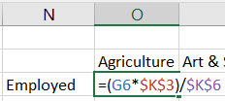

**Note:** a dollar sign ($) used to look the cell.

1. Calculate the chi-square statistics by using the following formula





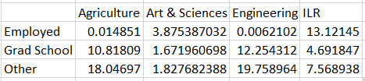

Do so for all cells, then use **SUM** function to calculate the chi-square statistic





1. To calculate the p-value, select the **Formulas** tab $⟹$**More Function $⟹$ Statistical $⟹$** **CHISQ.TEST**.

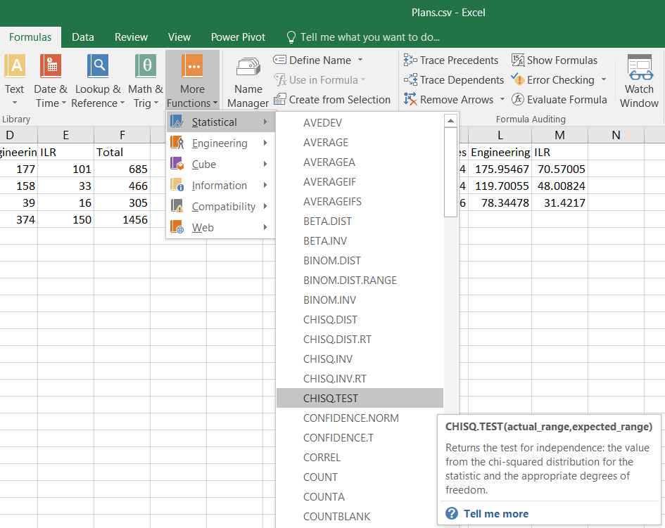

1. The **Function Arguments** box will appear, select the observed values to **Actual_range** and the expected values to **Expected_range**, and then click **OK**.

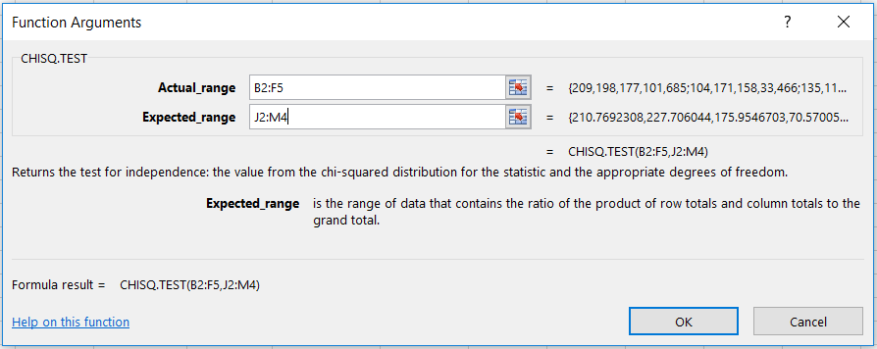

1. The result is:



**Note:** you may use the same steps for the chi-square test of independence.